**Software Engineer/software Developer**

**Developers :**

☞They can develop applications like WhatsApp, Paytm, google Pay, Facebook, twitter, banking App, telecom apps, Mobile apps.

**Software Tester**

☞Tester can test the application developed by developer

**✤Different types of application**

1. **Stand Alone application:**

⟹Any application runs on system it’s called as stand Alone /desktop/package application

1. **Web application**

⟹Any application runs on internet it’s called as web application

E.g., Facebook Gmail, bank application……….

1. **Distributed applications**

⟹One application interacting with another application is called as distributed application

1. **Mobile application**

⟹Any application runs on mobile application is called mobile application

**Vender:** sun Microsystems takeover by Oracle Corporation Pvt Ltd

**Author:** James Gosling

**Version**: java16

**✤Why java?**

⟹Open source

⟹Independent to platform

**✤What is java?**

⟹Is a programing language

⟹Can develop applications like standalone /web/distributed applications……….

⟹Application can be run on any platforms

⟹Object oriented programming language

**✤Statement⟹** meaning full information

**✤Program**: ⟹ set of statement

**✤Software**⟹ set of programs

**✤API (application programming Interface):**⟹set of packages

**✤Packages:** ⟹set of classes and interfaces

**Standalone Application: JSE API** —--> coreJava,jdbc

**web/distributed:** JEE API —--> jdbc,xml,jaxb,Restful Service

: JME API

*Note:* using J2SE API, we can develop standalone applications.

**✤Environment Set up**

☞J2sdk s/w (software)

☞Eclipse IDE(integrated **development environment)**

☞Notepad ++

Once download jdk (java development kit) s/w install

Once installation is complete….. Two folders it will be generated

1. Jdk version
2. Jre version

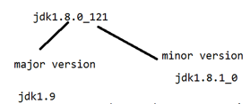

*Note:* If the micro version is changed then assume that previous version bug fixed up and released.

*Note:* Once changes happen on a major version assume that new features are added and released.

**✤JDK(java development kit)**  Developer +jdk

☞It provides the environment to develop applications or maintenance of the application

☞It represent JRE and development tools

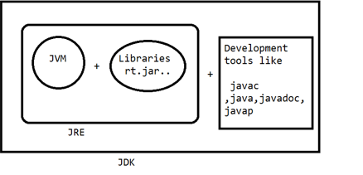

**JRE( Java Runtime Environment)**  (client)

☞It provides the environment to maintain or run the application

☞It represents jvm (java virtual machine) and libraries(rt.jar)

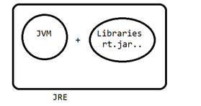

**JVM(Java Virtual Machine)**

☞JVM provides the environment to compile and run the applications.

☞Jvm loads the application and verify and execute

**✤What is class?**

**⟹**class is a template or blueprint.

**⟹**Using class keywords we can create the structure of a java.

**⟹**Class can have variables and methods

**Syx**: class <logicalname/classname>

{

// methods

// variables

}

**Eg**.

Class welcome

{

}

**✤Method**

**⟹**Method represent set of statement to perform specific task

Use: Reusuability

**Syx:** returnType logicalName/methodName(){ }

**✤What is the void method?**

**⟹**Void is a keyword , it doesn't return any information from the method

**✤Method can be classified two types**

**#userDefined methods**

**#Developer design methods**

Void add () void sub () void mul()

{

}

**✤Predefined methods**

**⟹**sunmicroSystem introduced predefined methods as part of the api

Public static void main(String[]args) —--> Execution will be started

{

}

**✤To print the information on console we can use**

system.out,println(“”);

**✤Compile java application**

Javac filename.java—> javac welcome.java

Public class welcome{

Public static void main(String[]args) {

system.out,println(“welcome to takeo”);

}

}

**✤.class contains bytecode format : 0 ,1**

**✤Compile time execution** :

Compile time it checks that any syntax mistakes are there or not…..

**✤Runtime exception:**

Application execution time it checks any logic mistakes then it generate Runtime exception

**✤What is variable:**

Variable can hold a value based on DataType

*Syx*: DataType variableName = variableValue;

**✤DataType can classified types**

1. Primitive Data Type
2. Non-primitive data type
3. User Defined datatypes
4. Predefined data types

Using these primitive data types can be present numeric, logic,character,fraction,decimals

**1.Primitive dataTypes(8)**

1. **Numerical DataTypes**
2. Integrated Data Types
3. Byte
4. Short
5. Int
6. Long
7. Floating point data types
8. Float
9. Double
10. **Character Data Types**
11. char
12. **Boolean Data Types**
13. Boolean

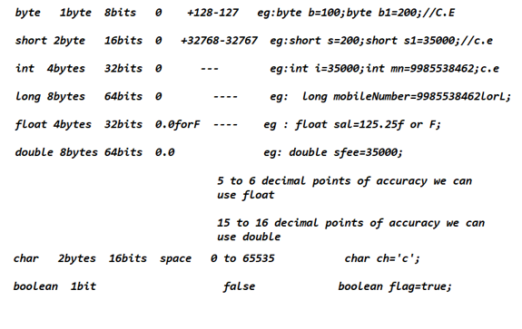

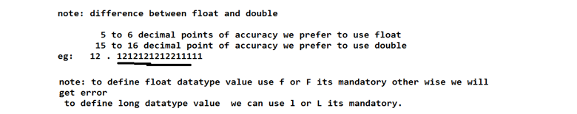

**✤Non-primitive data types**

1. **User Defined data types** :---->Using class name , we can define a data type is called a user defined data type

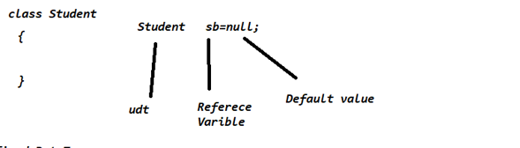

1. **Predefined data types**

Using a predefined class, we can define a datatype called a predefined data type. String is a predefined class, we can use as a dataType

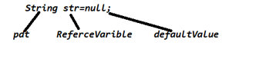

**Chart**

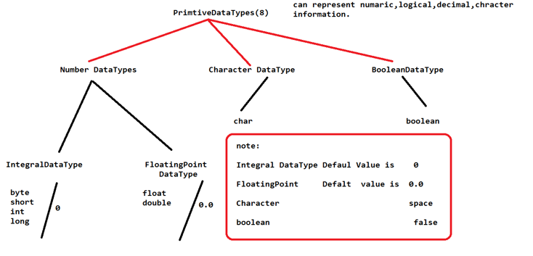

**✤Compiler: —---> Compiler.java** to .class file

*Note:* compilation time it checks that syntactically having any mistakes or not if we have any mistakes it gives compiler error.

**✤Interpreter:** . **—---> .**class to execution

*Note:* Interpreter will read line by line statement and execute…. If we have any logical errors it generates RunTime Error.